**How to Update Azure Automation Powershell Modules**

Introduction; As Microsoft develops and moves forward with their roadmap PowerShell will see a lot of changes and upgrades. Powershell being dependant on dotnet will come out with a new version every new version of dotnet. Below is the roadmap over the next 3 versions:

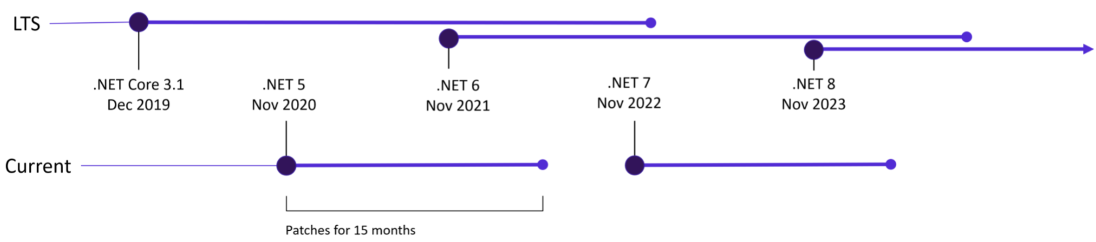

The following process will update all the modules at once but there is a little bit of leg work. Here are the steps:

1. Go to www.powershell gallery.com, search for the Az module and click the current version. Click on the little arrow next to “Product Details”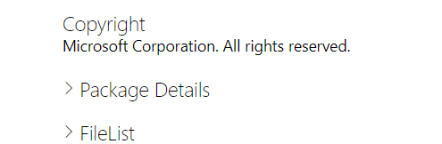
2. This is the list of all the dependencies and the updated versions of every Az. module. And paste it into a text file and you will have to parse the list into the proper format.

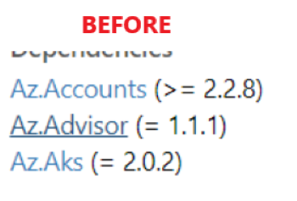 ----> 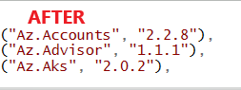

1. This can be done within notepad search and replace.
2. Replace “>= “ (notice the space after the equal sign with “ single quote
3. Replace “= “ (again the space) with “ single quote
4. Replace “ (“ with (type: quote space comma space) [“ , ] (notice the space before the ( in the beginning
5. Replace “)” with [“),] quote, close parenthesis comma (except for the very last line. Remove the comma
6. Replace “Az” with [(“Az] open parenthesis, quote, Az
7. When that is all done, open Powershell ISE and input into the script full script below:

(This is the full working script!)

$ErrorActionPreference = "continue"

connect-azaccount -usedeviceauthentication

$SubscriptionId = (get-azsubscription).Id

$ResourceGroupName = "%name of your resource group"

$accountName = "azure automation account name"

$AzDependencies = @(

("Az.Accounts" , "2.2.8"),

("Az.Advisor" , "1.1.1"),

("Az.Aks" , "2.0.2"),

("Az.AnalysisServices" , "1.1.4"),

("Az.ApiManagement" , "2.2.0"),

("Az.AppConfiguration" , "1.0.0"),

("Az.ApplicationInsights" , "1.1.0"),

("Az.Automation" , "1.6.0"),

("Az.Batch" , "3.1.0"),

("Az.Billing" , "2.0.0"),

("Az.Cdn" , "1.6.0"),

("Az.CognitiveServices" , "1.8.0"),

("Az.Compute" , "4.11.0"),

("Az.ContainerInstance" , "1.0.3"),

("Az.ContainerRegistry" , "2.2.2"),

("Az.CosmosDB" , "1.1.0"),

("Az.DataBoxEdge" , "1.1.0"),

("Az.Databricks" , "1.1.0"),

("Az.DataFactory" , "1.11.5"),

("Az.DataLakeAnalytics" , "1.0.2"),

("Az.DataLakeStore" , "1.3.0"),

("Az.DataShare" , "1.0.0"),

("Az.DeploymentManager" , "1.1.0"),

("Az.DesktopVirtualization" , "2.1.1"),

("Az.DevTestLabs" , "1.0.2"),

("Az.Dns" , "1.1.2"),

("Az.EventGrid" , "1.3.0"),

("Az.EventHub" , "1.7.2"),

("Az.FrontDoor" , "1.7.0"),

("Az.Functions" , "2.0.0"),

("Az.HDInsight" , "4.2.1"),

("Az.HealthcareApis" , "1.3.1"),

("Az.IotHub" , "2.7.3"),

("Az.KeyVault" , "3.4.2"),

("Az.Kusto" , "1.0.1"),

("Az.LogicApp" , "1.5.0"),

("Az.MachineLearning" , "1.1.3"),

("Az.Maintenance" , "1.1.0"),

("Az.ManagedServices" , "2.0.0"),

("Az.MarketplaceOrdering" , "1.0.2"),

("Az.Media" , "1.1.1"),

("Az.Migrate" , "1.0.1"),

("Az.Monitor" , "2.5.0"),

("Az.Network" , "4.7.0"),

("Az.NotificationHubs" , "1.1.1"),

("Az.OperationalInsights" , "2.3.0"),

("Az.PolicyInsights" , "1.4.1"),

("Az.PowerBIEmbedded" , "1.1.2"),

("Az.PrivateDns" , "1.0.3"),

("Az.RecoveryServices" , "3.5.0"),

("Az.RedisCache" , "1.4.0"),

("Az.RedisEnterpriseCache" , "1.0.0"),

("Az.Relay" , "1.0.3"),

("Az.Resources" , "3.4.1"),

("Az.ServiceBus" , "1.5.0"),

("Az.ServiceFabric" , "2.3.0"),

("Az.SignalR" , "1.2.0"),

("Az.Sql" , "2.17.1")

)

foreach ($module in $AzDependencies.GetEnumerator()) {

$moduleName = $module[0]

$moduleVersion = $module[1]

Write-Output "$($moduleName): $($moduleVersion)"

$result = Get-AzAutomationModule -AutomationAccountName $AccountName -ResourceGroupName $ResourceGroupName -Name $moduleName

if (($result -eq $null) -or (($result -ne $null) -and (($result.Version -ne $moduleVersion) -or ($result.ProvisioningState -ne "Succeeded")))){

New-AzAutomationModule -AutomationAccountName $AccountName -ResourceGroupName $ResourceGroupName -Name $moduleName -ContentLinkUri "https://www.powershellgallery.com/api/v2/package/$moduleName/$moduleVersion"

$updatedResult = Get-AzAutomationModule -AutomationAccountName $AccountName -ResourceGroupName $ResourceGroupName -Name $moduleName

}

}

1. Wait 30 minutes to an hour and check on it. It will take a bit to update. If any were to fail installing just modify the script to only run the ones that failed like:

$AzDependencies = @(

(“Failed” , “dependency1”),

(“Failed”, “dependency2”)

Etc

) ←--- close it and run the rest of the script..

6. If it still fails, delete it, and install it from the gallery

7. When you update this, you need to make the environment match with the same version, go to the url below, download the .msi, upload it into the environment and install it on all the VMs

<https://github.com/Azure/azure-powershell/releases>